- Write simple fact for the statements using PROLOG
  - Ram likes mango
  - Seema is a girl
  - Bill likes Cindy
  - Rose is red
  - John owns gold.

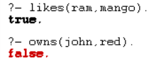

- Write a Prolog program that calculates the sum of integers from 1 to n. Define a predicate ‘sum_up_to_n’ where the first argument is 'n' (an integer) and the second argument is the result of the sum. The sum should be computed recursively.

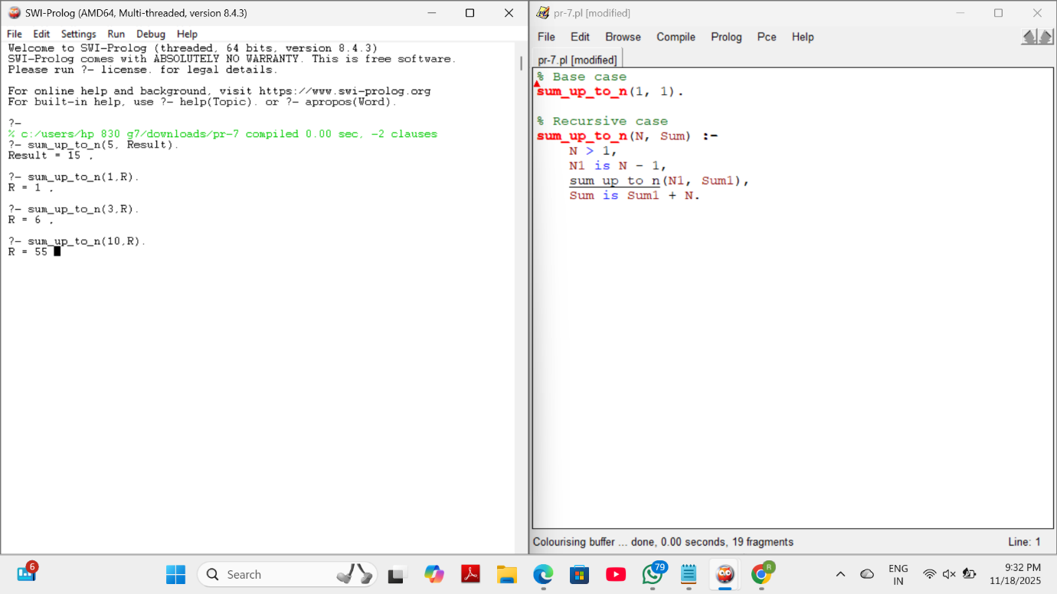

- In the following sections, we'll illustrate constraint programming (CP) by a combinatorial problem based on the game of chess. In chess, a queen can attack horizontally, vertically, and diagonally. The N-queens problem asks:
  - How can 4 queens be placed on a 4x4 chessboard so that no two of them attack each other?

  - For the above problem, you have to show one possible solution using Prolog program.

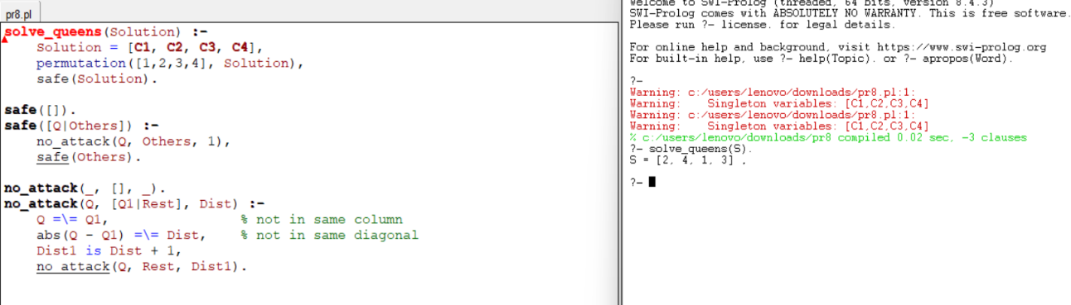

- Write a Prolog program that calculates the factorial of a given number. Your program should include a predicate factorial that takes an input number and computes its factorial. You can use recursion for this task.
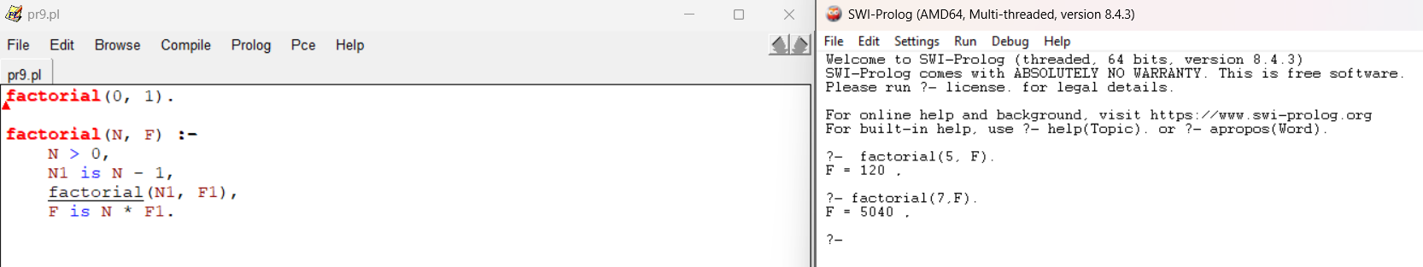

- Write a Prolog program that calculates the nth Fibonacci number. Your program should include a predicate Fibonacci that takes an input position n and computes the Fibonacci number at that position. Use recursion to implement the Fibonacci sequence.

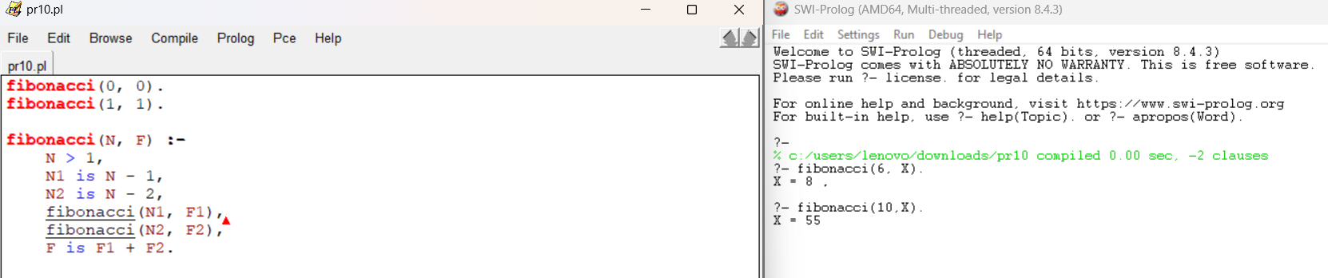

- Write a Prolog query to determine if a specific bird can fly or not. Please provide the Prolog query and its output for the following birds:
  - Sparrow
  - Penguin
  - Eagle
  - Crow (A bird not mentioned in the provided facts).

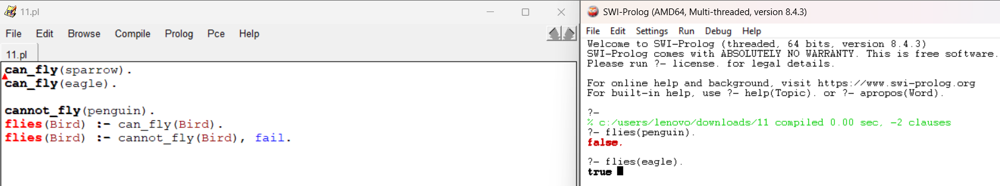

- Imagine you are managing a database that stores information about individuals, including their names and dates of birth (DOB). Define at least five individuals with their names and DOBs. Write Prolog queries to perform the following tasks:
  - Retrieve the DOB of a specific person given their name.
  - Find all individuals who are older than a certain age (e.g., 30 years old) based on their DOBs.
  - Determine who is the youngest person in the database.
  - Check if a specific person is older than another specific person.
  - Your program should include appropriate facts and rules for these tasks. Make sure to provide sample queries for each task as well.

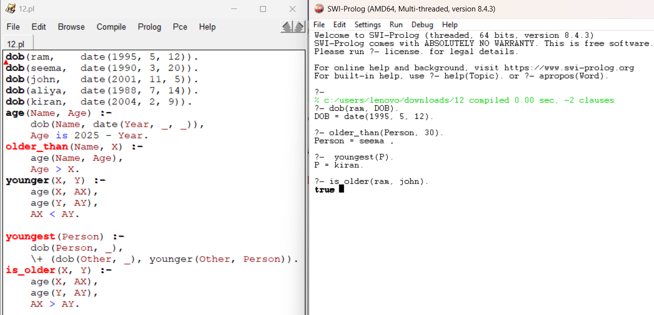

- Create a Prolog program for backward chaining questions, you typically define facts and rules that describe your domain and then use queries to find the answers to specific questions. You have to create a knowledge base about animals and answer questions about whether an animal is a mammal or a bird.

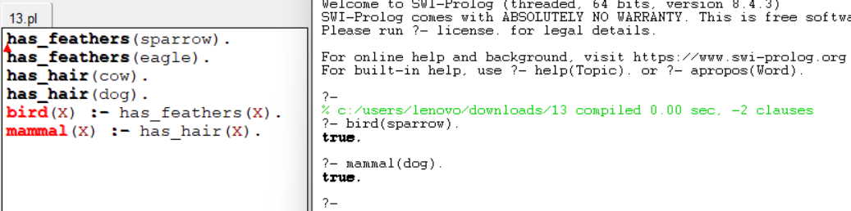

- Create a Prolog program to suggest a dieting system based on a specific disease involves defining rules and facts for different diseases and their corresponding dietary recommendations. Use three common health conditions: diabetes, hypertension, and obesity.

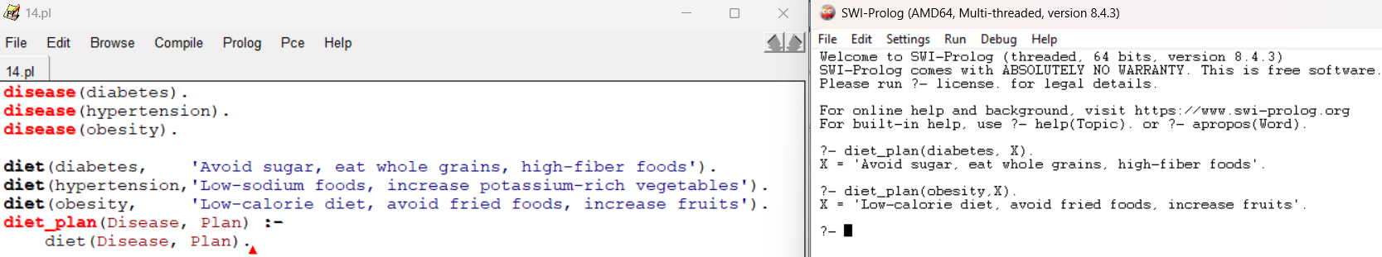

- Using Prolog, you have to solve the problem of finding fruits and their colors using backtracking by defining facts and rules that describe the relationships between fruits and colors. Take sample fruits of 8 no’s.

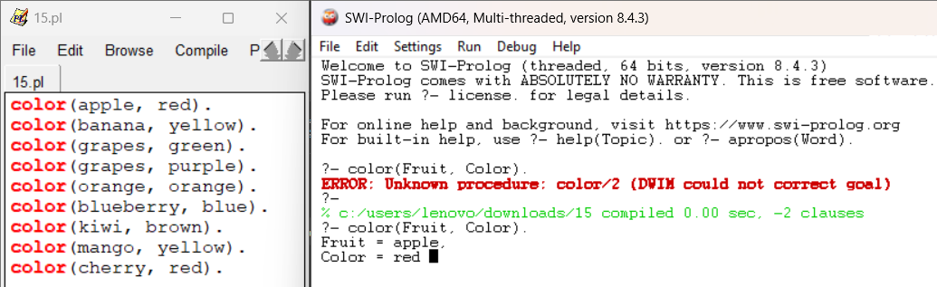

- Create a Prolog program that generates exam questions related to students, teachers, subjects, and codes. In this program, you have to create a knowledge base with some facts, and then generate questions based on that knowledge. The questions will be in the format of "fill in the blank".

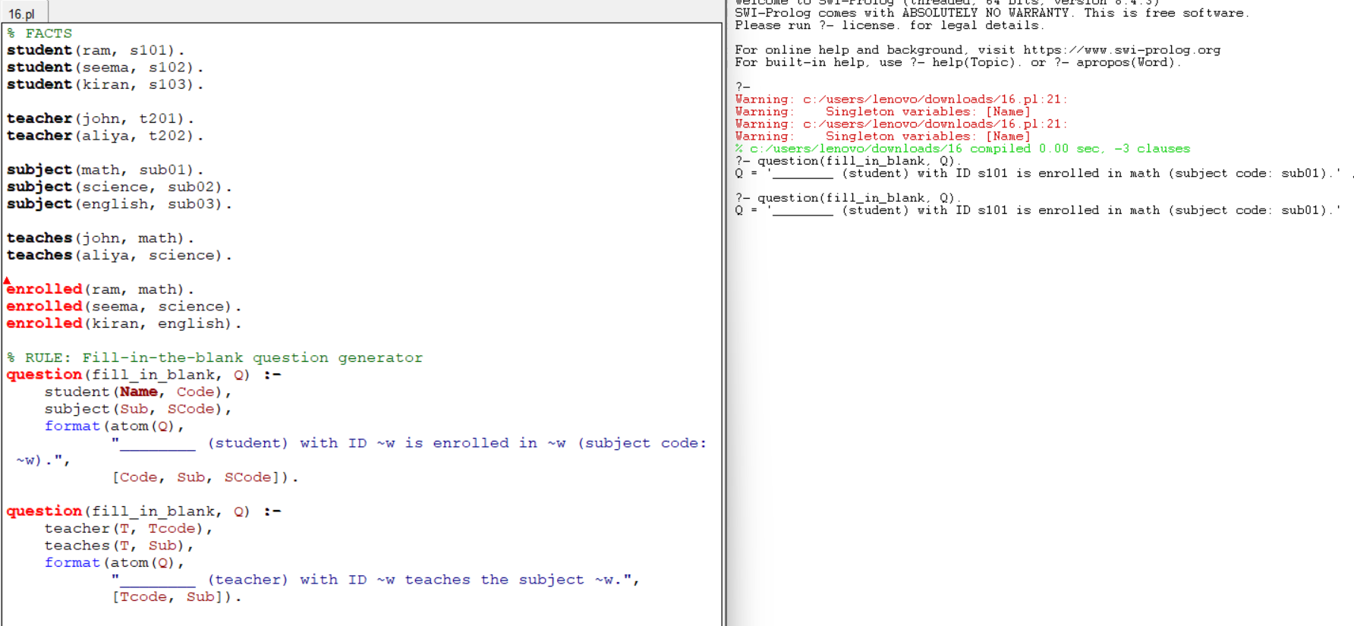

- In forward chaining, you start with initial facts and rules and iteratively apply the rules to derive new facts until a goal is reached. Define a simple scenario with a few rules and facts. Using prolog, you have to determine whether someone is a parent based on their gender and whether they have a child.

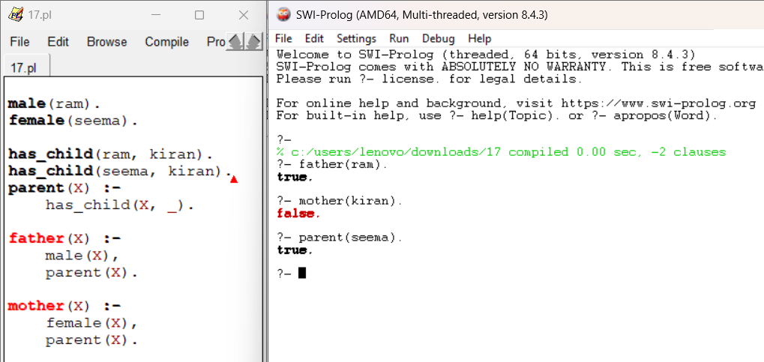

- Write Prolog facts to represent the following information about specific planets in the PLANETS database:
  - Planet Mercury's distance from the Sun and mass in Earth masses
  - Planet Saturn's orbital period and day length in Earth days and hours, respectively
  - Write a Prolog rule to find the distance between two planets based on their positions from the Sun.
Provide an example query to find the distance between Planet Venus and Planet Jupiter
  - Create a Prolog query to find all planets that are closer to the Sun than Planet Earth. List the planets that match these criteria.

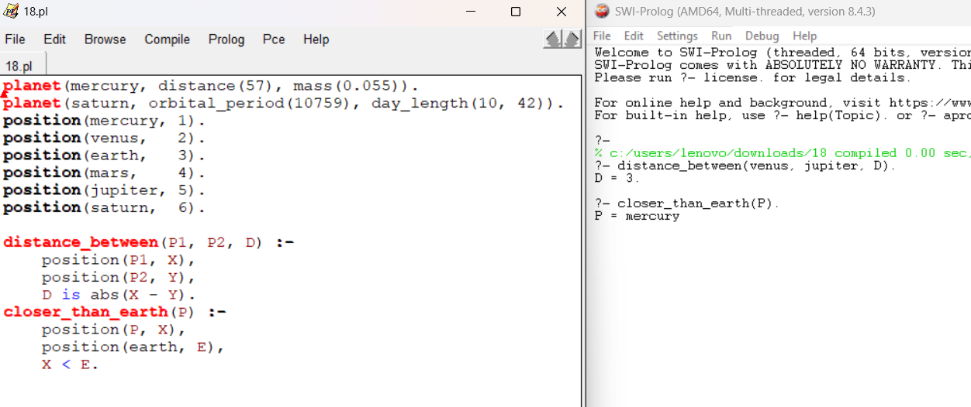

- In this program, define symptoms and conditions, create rules for diagnosis, and provide an interactive interface for patients to input their symptoms. The program then tries to diagnose the patient based on the symptoms provided. Use prolog program to implement the above scenario.

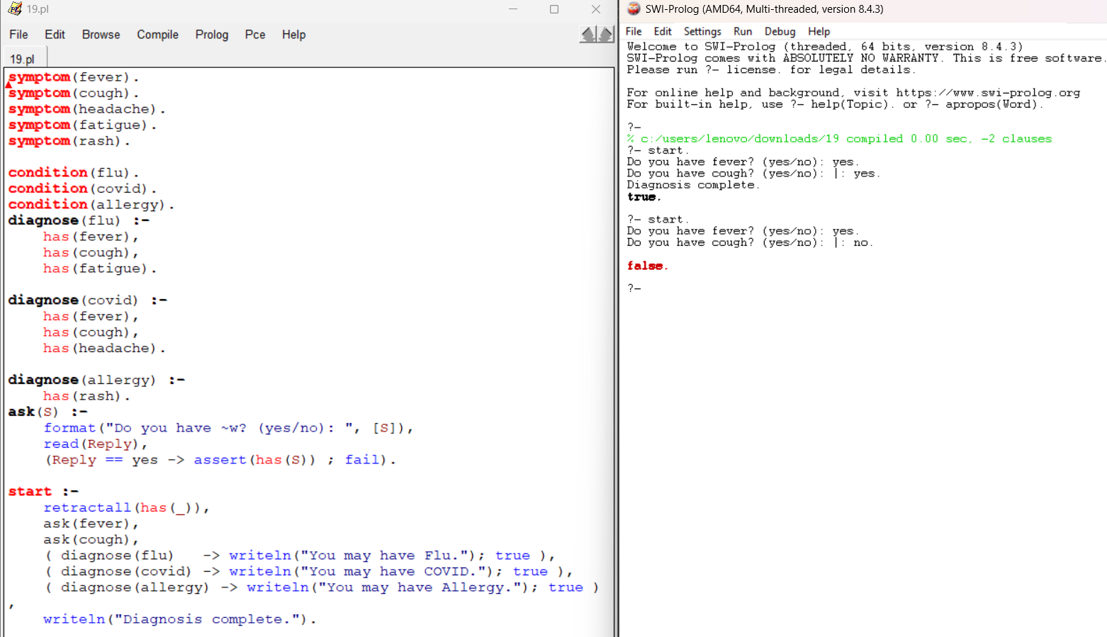

- You are tasked with implementing a family tree in Prolog. Use the following information to create a family tree database:
  - John is the father of Lisa.
  - Mary is the mother of Lisa and Mike.
  - Lisa is the sister of Mike.
  - Tom is the father of Mary.
  - Mike is the father of Emma.
  - Emma is the mother of Olivia.
  - Tom is the grandfather of Olivia.
Write Prolog predicates and rules to represent this family tree and answer the following queries:
- Who is the father of Emma?
- Who is the sister of Mike?
- Who is the grandmother of Olivia?
- Is John the grandfather of Olivia?.

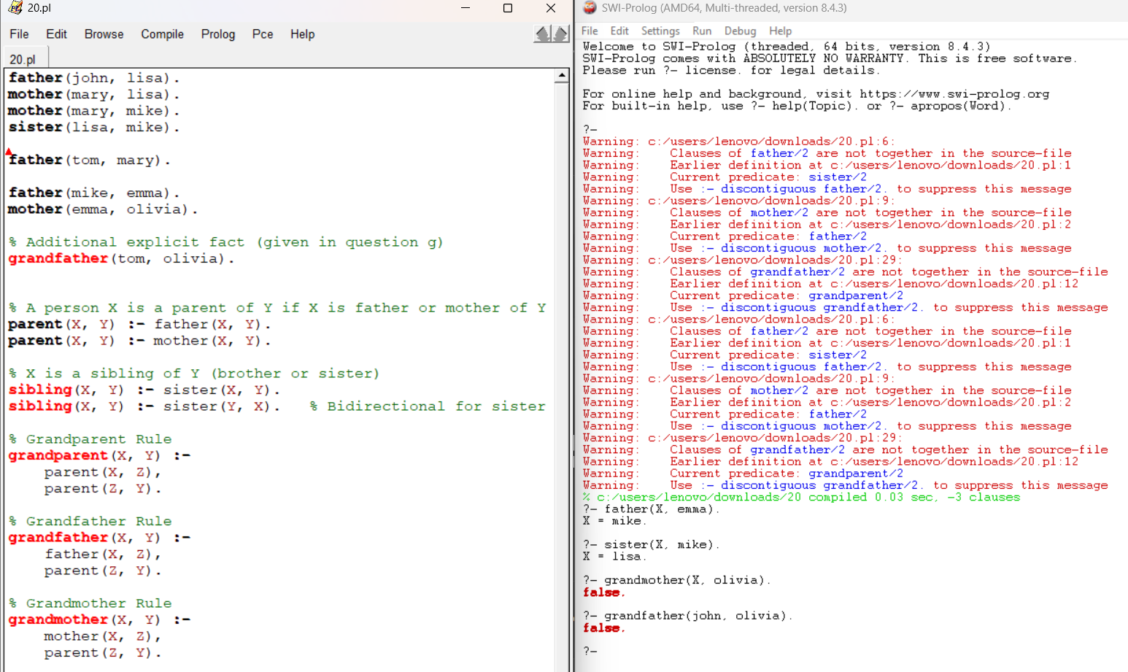

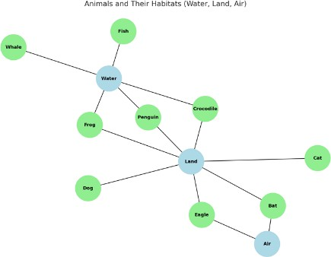
- Write a Prolog program to represent animals and their habitats. Include rules to determine which animals live in water, on land, and can fly.

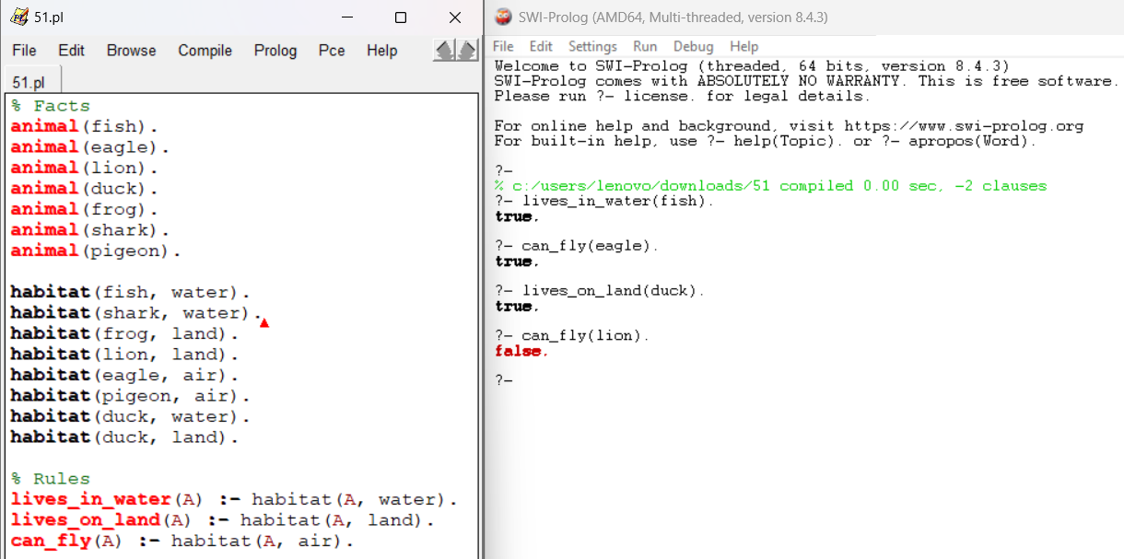

- Create a Prolog program for medical diagnosis of fever. Include symptoms such as cough, cold, headache, malaria, typhoid, and flu.

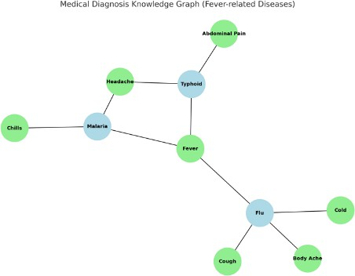

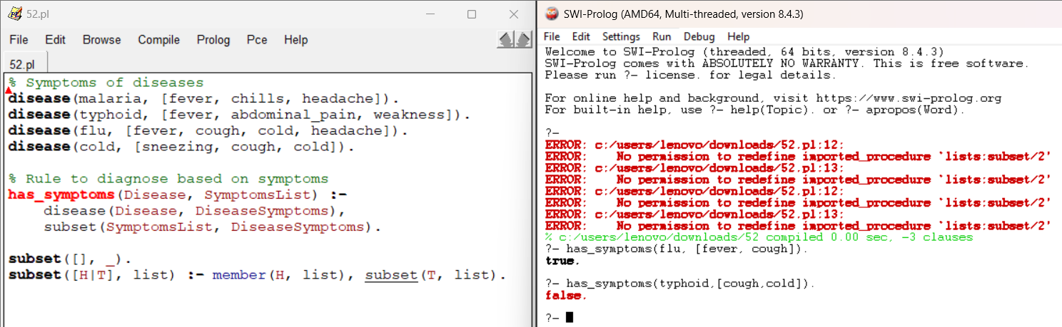

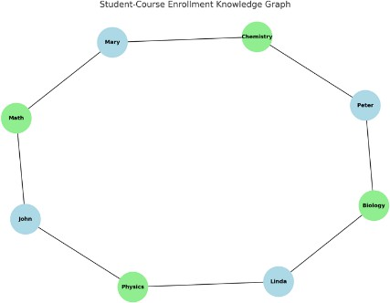
- Develop a Prolog knowledge base for a student-course enrollment system. The program should answer queries such as “Which courses does a student take?” and “Which students are enrolled in a course?”.

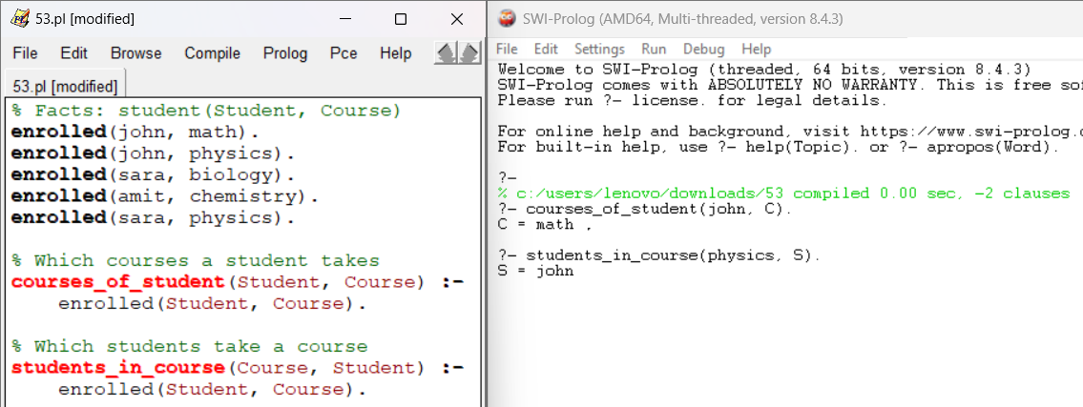

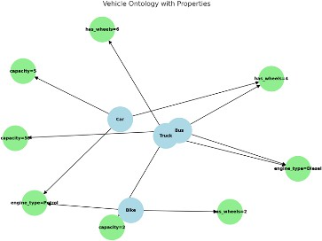
- Write a Prolog program to represent a small ontology of vehicles (car, truck, bike, bus) with their properties. Include reasoning rules to classify vehicles based on attributes.

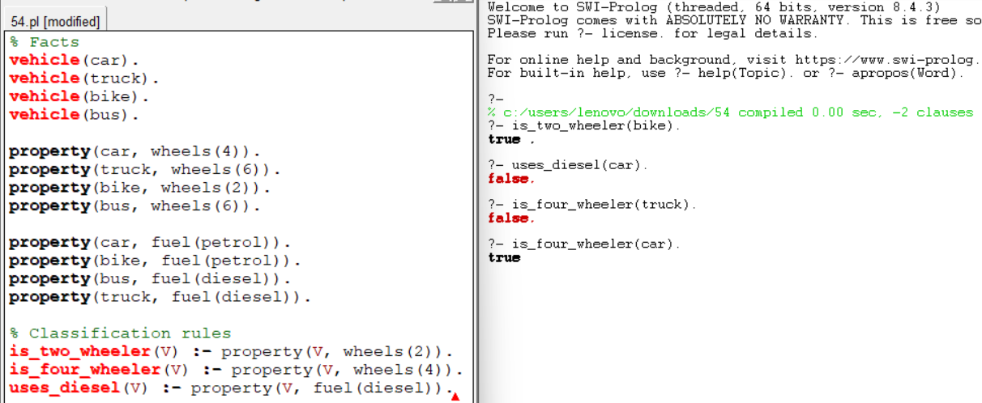

- Develop a Prolog program for restaurant menu recommendations. Define facts about dishes (veg/non- veg, spicy/mild) and rules for recommending dishes to customers.

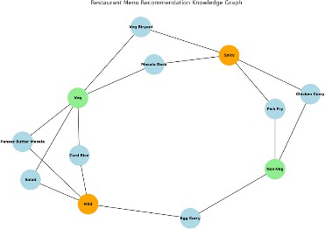

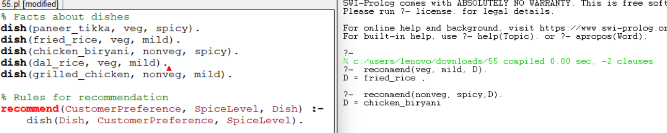
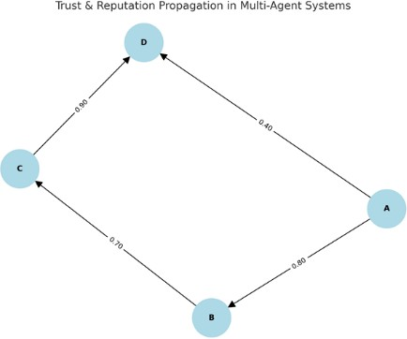
- Write a Prolog program to simulate trust and reputation in multi-agent systems. Include rules or reputation propagation.
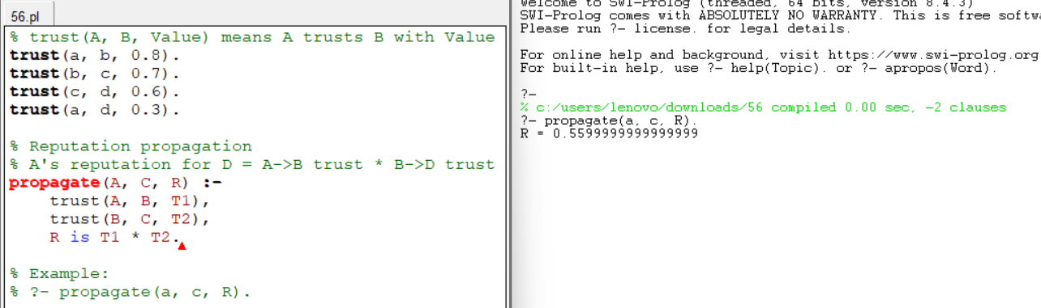

- Write a Prolog program to demonstrate backward chaining for a simple legal reasoning system (e.g., whether a person is eligible to vote).

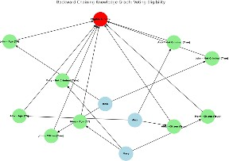

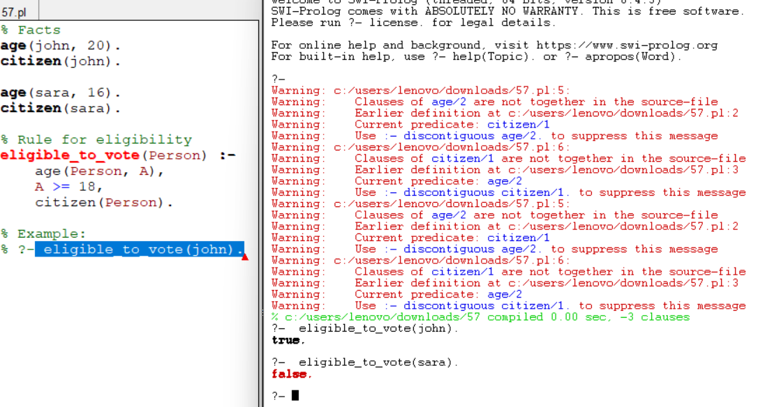

- Write a Prolog program for semantic network representation of relationships among concepts such as
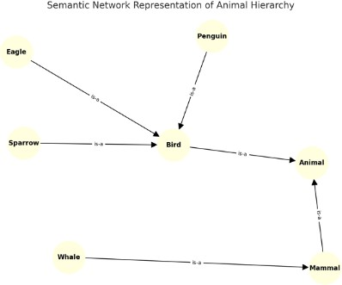
“bird → animal,” “sparrow → bird,” and queries to infer hierarchy.

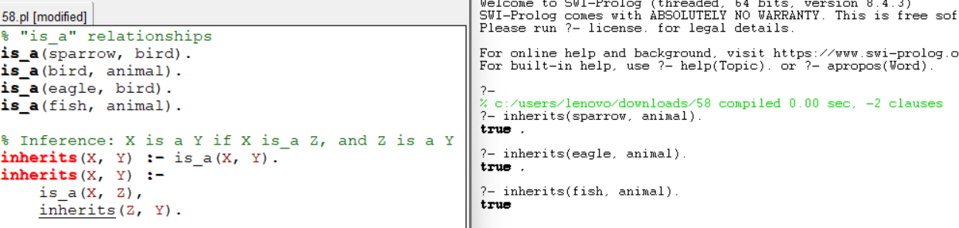

- Write a Prolog program that models an argumentation framework among agents and checks whether a given argument is accepted or rejected.
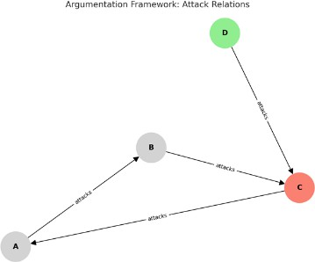

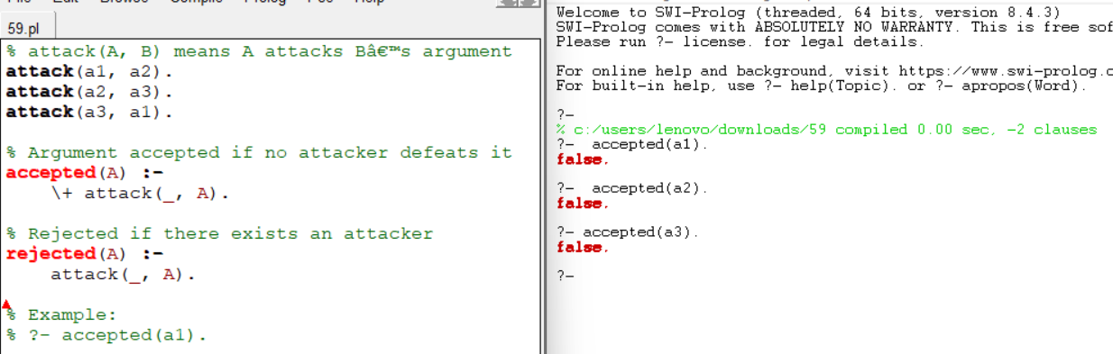

- Write a Prolog program that represents knowledge using frames. Create frames for “Car,” “Electric Car,” and “Hybrid Car,” and show inheritance of attributes.
